Mission 4 - Activity Sheet
Story so far
Our Alien, Alex, is internet connected, has locked his device securely and installed apps and software.
Your task is to help Alex create accounts, make passwords and decide on any other ways to keep his identity and location details as private as possible.

Questions you will need to consider looking into.

- Are email address(es) and the way they are worded important
- Is a password enough
- How do you make passwords unique and complex enough
- How should Alex store his account details
- Are some accounts more important than others
- Besides passwords, what other technologies are there to help increase security
- What is defence in depth – and should Alex use it, and how*

Next session objective – discussion topic
What advice are you going to give Alex about cresting and securing accounts, so that they are not accessed by those looking to find hm/her. Is there a balance between enough security but is still convenient to use.

Everyone likes to learn in their favourite way. Here is a list of things you may want to look at if you are stuck or what an idea of things to think about. There are lots more out there, perhaps you can find better ones!

Basics of cyber security advice - Cyber Aware from the NCSC
https://www.ncsc.gov.uk/cyberaware/home

Guess the Password – Online Game using data from NCSC
https://www.sporcle.com/games/g/passwords
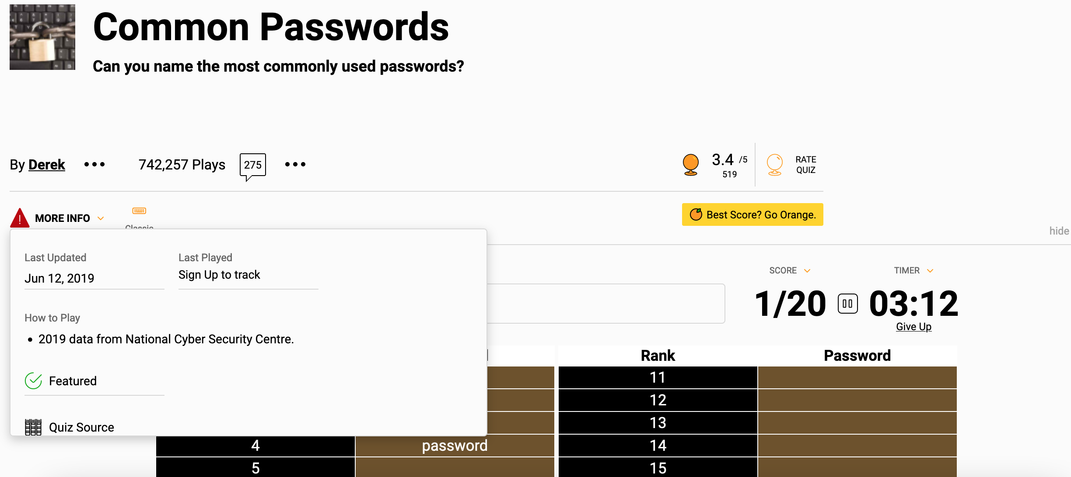

How to create Strong Passwords – Activities, Conversation Guide, Video and Kahoot
https://www.trendmicro.com/internet-safety/for-kids/cyber-academy/how-to-create-strong-passwords
https://www.youtube.com/watch?v=PQgUe8MBjG4

What is Two-Factor Authentication – Activities, Conversation Guide, Video and Kahoot
https://www.trendmicro.com/internet-safety/for-kids/cyber-academy/what-is-two-factor-authentication
Password Safety Tips for Kids – 2 min read, easy to understand
https://www.benetpositive.org/post/password-safety-tips-for-kids

DinoPass – Fun Password Generator for Kids
https://www.dinopass.com/

Creating Strong Passwords
https://edu.gcfglobal.org/en/internetsafety/creating-strong-passwords/1/

What is Phone Verification and is it Safe to Use it?
https://edu.gcfglobal.org/en/internetsafety/i-have-to-provide-my-phone-number-using-phone-verification-/1/

Social Engineering – Quick Guide
https://www.getcybersafe.gc.ca/en/resources/social-engineering-how-cyber-scams-trick-us

*I asked Chat GPT to explain defence in depth:
Think of your home. You have different layers of security to protect your home from different types of dangers. For example, you might have a fence to keep people out, a lock on your front door to keep burglars out, and an alarm system to alert you if someone breaks in.
In the same way, defence in depth is a strategy that involves using multiple layers of protection to keep a computer system safe from hackers and cyber-attacks. These layers can include things like firewalls, anti-virus software, strong passwords, and regular updates to software.
If one layer of protection fails, there are still other layers that can prevent or limit the damage from the attack. This is important because hackers are constantly finding new ways to attack computer systems, so having multiple layers of protection helps ensure that your system is secure even if one layer is compromised.
By using defence in depth, we can make it much harder for hackers to break into a computer system and steal sensitive information or cause damage.

