CyberFirst Schools/Colleges
Application Form (England)
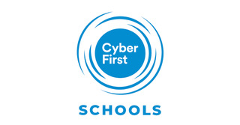

© Crown Copyright 2021, The National Cyber Security Centre

Contents
Your contact details 4
Additional Information 4
Data Protection 4
Introduction 5
Application Guidance 5
Assessment 5
Scoring 6
Requirement 1 – (Rating 0 to 4) 10
Additional Guidance 10
Requirement 1 (Answer sheet 1 of 1) 11
Requirement 2 - (Rating 0 to 4) 12
Requirement 2 (Answer sheet 1 of 2) 13
Requirement 2 (Answer sheet 2 of 2) 14
Requirement 3 - (Rating 0 to 4) 15
Additional Guidance 15
Requirement 3 (Answer sheet 1 of 1)Requirement 4 - (Rating 0 to 4) 16
Additional Guidance 17
Requirement 4 (Answer sheet 1 of 2) 18
Requirement 4 (Answer sheet 2 of 2) 19
Requirement 5 - (Rating 0 to 4) 20
Additional Guidance 20
Requirement 5 (Answer sheet 1 of 1) 21
Requirement 6 - (Rating 0 to 4) 22
Additional Guidance 22
Requirement 6 (Answer sheet 1 of 1) 23
Requirement 7 - (Rating 0 to 4) 24
Additional Guidance 24
Requirement 7 (Answer sheet 1 of 2) 25
Requirement 7 (Answer sheet 2 of 2) 26
Requirement 8 - (Rating 0 to 4) 27
Additional Guidance 27
Requirement 8 (Answer sheet 1 of 2) 28
Requirement 8 (Answer sheet 2 of 2) 29
Requirement 9 - (Rating 0 to 4) 30
Additional Guidance 30
Requirement 9 (Answer sheet 1 of 2) 31
Requirement 9 (Answer sheet 2 of 2) 32
Requirement 10 - (Rating 0 to 4) 33
Additional Guidance 33
Requirement 10 (Answer sheet 1 of 1) 34

Please note: ALL sections need to be completed

Your contact details
Name of applicant: Example application
Name of School/College: Gold Example School
Type of school:
School/College Address (inc postcode):
Contact Email: CFschools@ncsc.gov.uk
Contact Phone:

Additional Information
Number of students in school: X
Number of students who study computer science at, include gender split in %
GCSE: X
A level: X
How many teachers are teaching stem subjects? X
How many free school meals are provided? X

We want to thank Wyedean School and Cardiff High School for letting us use their gold application as an example.

Data Protection
We handle all data according to our requirements under the Data Protection Act 2018. Any data provided will be handled in accordance with the purposes it was requested, and you have certain rights regarding its ongoing use. For more information, please see our Privacy notice (https://www.gchq.gov.uk/section/about-this-website/privacy)
Please mark the box with an X to confirm that you agree to any personal data submitted in this form being held and used in relation to CyberFirst activities.
At any time, you can rescind your permission. Please contact CyberFirst_Unsubscribe@ncsc.gov.uk
I agree ☒
Date: Click or tap to enter a date.

Introduction
Thank you for applying to be a CyberFirst School/College. In this application form you will find Sections 1- 10 that require completion. To successfully complete this application, you will need to refer to the “CyberFirst Schools/Colleges call for applications” document. If you have not already done so, you can download a copy of the document at https://www.ncsc.gov.uk/cyberfirst/ . We recommend you read thoroughly through the document before attempting to complete this application. Any supporting documentation for each requirement should clearly identify which requirement it relates to and must be submitted separately to cfschools@ncsc.gov.uk. Please label the subject heading with your school/college name and your name.

Application Guidance
All sections of this application form must be completed and submitted, along with any additional supporting information to cfschools@ncsc.gov.uk by 22.00hrs on 18th June 2021.
Please complete the application, typing or writing your answers within the relevant pages marked ‘Answer Sheet’ using single spacing and using size 11/12 Calibri or Arial font.

Assessment
Applications within scope will be assessed by an assessment panel that will include representatives from government, industry and academia. Each application will be read and scored independently by a minimum of three members of the Assessment Panel. Panel members may go back to schools/colleges for clarification questions.

Scoring
At the Assessment Panel meeting, Panel members will present their scores and the rationale for their scores. In terms of providing evidence to meet the assessment criteria, each scored section of each application will be marked using the following scale:
Scoring Interval | Definition
0 | Fail - No response or no response capable of assessment has been submitted, or the response does not address the criteria of the requirement.
1 | Preliminary Fail - The response meets some but not a majority of the requirement and/or insufficient evidence is provided to substantiate the response. There are significant deficiencies in the response.
2 | Bronze - The response meets the majority but not all of the requirement and there are minor deficiencies in how the application addresses the remaining criteria. For those parts of the requirement that are met, sufficient evidence to substantiate the response is provided.
3 | Silver - The response meets the requirement in full and is supported by evidence that substantiates the response. All of the criteria of the requirement are satisfactorily covered by the response.
4 | Gold - The response meets and, in some places, exceeds the requirement. The response is backed up by substantial and convincing evidence.

Scores for each requirement will first be awarded individually by the appointed evaluators and then discussed at a moderation meeting (or meetings) at which a final score for that requirement will be decided and recorded.
Each requirement has equal weighting, and the overall application will be assessed based on the total points awarded by the Panel across all requirements as follows:
Scoring Interval  (out of 40) | Level of Recognition
0 – 15 | Fail
16 – 25 | Bronze
26 – 35 | Silver
35+ | Gold

The Panel’s decision is final. There is no maximum number of successful applications for CyberFirst School/College’s. A successful application requires that each scored section must achieve a Pass or achieve a threshold score of 2.

Scoring against all levels
At the Assessment Panel each application will be assessed against each of the requirements outlined in the table below. Each application should address each section below.
ID | Requirements | Gold | Silver | Bronze | Scoring System
1 | Signed statement of support from the proposed CyberFirst school/college head teacher and supporting core team.  (up to one side of A4 plus any supporting information) | ✓ | ✓ | ✓ | 0-4
2 | Description of the proposed CyberFirst School/College cyber security education strategy  (up to two sides of A4 plus any supporting information) | ✓ | ✓ | If there is not currently a cyber education strategy, the School/College should demonstrate a plan to attaining one within the next year. | 0-4
3 | Must have a well-defined core team comprising specialist * staff and must be able to show that it works effectively and has regular engagement.  (up to one side of A4 plus any supporting information) | ✓ | ✓ | If there is not currently a core team, the School/College should demonstrate how it will create one within the next year. | 0-4
4 | Proposed CyberFirst School must offer computing or equivalent at all key stages that it provides provision for. Proposed CyberFirst College must offer computing or equivalent at Level 2/Level 3.  (up to two sides of A4 plus any supporting information) | ✓ | If the School/College does not offer computing at all KS currently, it must demonstrate how it intends to do so within the next year. | If the School/College does not offer computing at all KS currently, it must demonstrate how it intends to do so within the next year. | 0-4
5 | Description of the actual/proposed CyberFirst schools/colleges teaching CPD opportunities.  (up to one side of A4 plus any supporting information) | ✓ | ✓ | If the School/College does not offer CPD opportunities at all, it must demonstrate how it intends to do so within the next year. | 0-4
6 | The proposed CyberFirst school must offer a minimum number of hours per week in KS3 computing and/or other cross curricular lessons if school provides provision for KS3.  (up to one side of A4 plus any supporting information) | At least 1.5 hours a week | At least 1 hour a week | If the School/College does not offer KS3 computing currently, it must demonstrate how it intends to do so within the next year. | 0-4
7 | Description of the proposed CyberFirst school/college enrichment activities in Computing/Cyber Security at all Key Stages.  (up to two sides of A4 plus any supporting information) | A description of the proposed activities that demonstrates at least 1.5 hours of activity per week | A description of the proposed activities that demonstrates at least 1-hour of activities per week | A description of the proposed activities with no time commitment | 0-4
8 | Description of the proposed CyberFirst School/College feeder schools (where relevant) engagement in computing/cyber security.  (up to two sides of A4 plus any supporting information) | ✓ | If the School/College does not currently engage in computing/ cyber security, it must demonstrate how it intends to do so within the next year. | If the School/College does not currently engage in computing/ cyber security, it must demonstrate how it intends to do so within the next year. | 0-4
9 | Description of the proposed CyberFirst School/College external engagement activities and plans in computing/cyber security.  (up to two sides of A4 plus any supporting information) | The School/College details both current and future plans | The School/College details both current and future plans | The School/College details future plans only | 0-4
10 | Description of how and what the proposed CyberFirst School/College participates in or advertises CyberFirst activities or equivalent.  (up to one side of A4 plus any supporting information) | ✓ | ✓ | ✓ | 0-4

Requirement 1 – (Rating 0 to 4)
The proposed CyberFirst School/College must provide a signed Statement of Support from the Head Teacher showing support for the school/college’s application to be recognised as a CyberFirst School/College. By way of example, it is suggested that the School/College’s senior management use the Statement of Support to demonstrate its continued commitment to:
- Computing/Computation/Cyber security in the School/College’s future strategy
- Investment, either financial or time, in the area of computing, computation and/or cyber security
- Supporting proposed external engagement and enrichment activities
- Working to improve cyber security awareness and behaviours for pupils and staff across the school/college
- Maintaining its cyber security strategy
In addition, Gold applicants must provide the additional two points below:
- School/College has taken appropriate steps to protect itself from cyber incidents e.g., by demonstrating 10 steps, cyber essentials (https://www.ncsc.gov.uk/cyberessentials/overview)
- Appointment of a CyberFirst School/College’s lead within the School/College who will be the main point of contact for NCSC.
☐0 - Fail - The proposed CyberFirst School/College has failed on ALL points

☐1 - Preliminary Fail - The proposed CyberFirst School/College has tried to provide points 1-5

☐2 - Bronze - The proposed CyberFirst School/College must provide points 1 – 5

☐3 - Silver - The proposed CyberFirst School/College must provide points 1 – 5

☒4 - Gold - The proposed CyberFirst School/College must provide all the points from 1-7

Additional Guidance
Please provide a response to each bullet. We will be seeking evidence against all points

Requirement 1 (Answer sheet 1 of 1)

At our gold school we believe passionately in equipping our students with the knowledge and skills to be effective and active citizens in a rapidly evolving, digital, global society. As a school, we were early pioneers of computer science and cyber education having first delivered computer science in the 1980s and we have continued this tradition until the present day. We recognise that cyber and computing education provides students with the know-how to be safe online but also the qualifications and experience to be successful in the workplace. Our school curriculum puts equal emphasis on computer science as it does other Ebacc subjects and as such we have a team of six qualified teachers of computer science, two of whom are on the school’s Senior Leadership Team. Having this expertise within the leadership team ensures that cyber education has a parity of esteem with other subjects and features significantly in the school strategic plan.

Our passion for the cyber curriculum has ensured that the most popular university subject for our students is the field of computer science. Selection at KS4 is strong and aligned in number to other Ebacc subjects. However, we accept that not every child will choose to select to study this subject beyond KS3. For this reason, we have also integrated cyber education in to our pastoral curriculum for all students, 11-18. We recognise that students need to be equipped to deal with the realities of living their lives online. Young people need to be cyber-aware and know how to protect themselves and avoid the pitfalls of cyber-criminality.

Our school places huge emphasis on super-curricular opportunities. To engage young people effectively they need to experience and understand the implications of life online. Where better to do this than through the direct engagement of industry and universities. They, better than anyone, have the illustrations to bring learning to life and to raise the aspirations of our young people. It would be all too easy to assume that children have the input of parents and families when considering career opportunities. Our rural location on the edge of the Forest of Dean can be limiting but through our programme of external speakers, visits to the workplace and direct mentoring our children have benefitted from exposure to leading industries. Not only has this helped to meet the requirements of Gatsby benchmarking in cyber education, it has also succeeded in raising the aspirations of so many of our young people. Where previously some students were facing low horizons they now have the determination and passion to succeed beyond their locality and the tourism and farming industries therein.

As a CyberFirst school we are committed to working with our primary school partners. The earlier that we can engage and connect with our youngsters the more secure we can make them and their families. For young people, computers and the world of cyber is their normal. However, it is important to recognise that whilst some young people are exposed early to computer science through home PCs and the likes of minecraft and scratch, for others this is limited to games consoles and mobile phones where there is little access to computer science education. For this reason, we have developed a series of events and activities to support computing and cyber education in KS1&2 within

their home school setting.
Moving forward in to the 2020’s, we understand the importance of this key element of the curriculum. We are steadfast in our belief that cyber education should be integral to every school’s curriculum. We are committed to working with CyberFirst to wave the flag and share our excellence in cyber education regionally and nationally.

It gives us great pleasure to submit this application to become a Gold CyberFirst School.

Yours sincerely
Gold Example School core team to lead the CyberFirst Gold special school status will comprise the following dedicated staff who have expertise in the highlighted areas. All have shown commitment to cyber education skills and growth since 2018 and have a track record of success, apparent in the supporting evidence within this application.

CyberFirst Schools Lead | Teacher 1 (Head of Applied Learning and Computer Science)
Computing/Cyber Security Strategy Lead Whole School | Teacher 2 (Assistant Principal Academic)
Cyber Security Financial Lead | Teacher 3 (Vice Principal: Finance and Business)
External Engagement, Communication and Outreach Leads | Teacher 3 (Curriculum) Emma Williams (Enrichment and Cross Curricular), Teacher 5 (Careers)
Cyber security awareness, diversity and Inclusion Lead | Teacher 6 (Assistant Principal: Pastoral)
Computing and Communications Infrastructure & System Protection | Teacher 7 (Operations Manager)

Requirement 2 - (Rating 0 to 4)
The proposed CyberFirst School/college must have a strategy/plan for how it will consolidate and develop cyber security education. By way of example, this might include plans for:
- Growth in staff numbers and/or expertise
- Continuing and/or growing computing/computation at Key Stage 3-A/AS Level and seeing a steady increase in numbers
- Further promotion of computing/cyber security across the school/college
- Continued and/or deepening engagement with industry and other schools/colleges
- Keeping up to date with computing/cyber security education, for example, actively attending courses on an annual basis
- Demonstrate how it is integrating cyber and cyber security into a range of differing subject across the curriculum.
- Engagement with the NCCE hub, for example:
  - Whether the proposed CyberFirst School/College is affiliated with a computing hub
  - Whether the proposed CyberFirst School/College is taking part in any of the NCCE gender balance initiatives
  - Whether the proposed CyberFirst School/college has any teachers going through any of the NCCE CPD, Isaac or have used the resources to deliver lessons.

☐ 0 - Fail - The proposed CyberFirst School/College has failed on ALL points.

☐ 1 - Preliminary Fail - The proposed CyberFirst School/College has provided a limited strategic plan.

☐ 2 - Bronze - The proposed CyberFirst School/College must have a strategy/plan for aspiring to be a CyberFirst SILVER/GOLD School/College.

☐ 3 - Silver - The proposed CyberFirst School/College must have a strategy/plan for aspiring to be a CyberFirst GOLD School/College.

☒ 4 - Gold - The proposed CyberFirst School/College must have a strategy/plan for how it will consolidate and develop cyber security education.

Requirement 2 (Answer sheet 1 of 2)
Our cyber education strategy aims to encourage young people to engage with computer science and the application of cyber security. We aim to provide opportunities for all to engage with industries and universities to develop expertise and resources.
Our vision is to encourage a diverse range of students into taking computer science and cyber.
As a school we aim to:
-Increase female update at GCSE and A level
-Develop the curriculum to support learning and raise student outcomes in computer science
-Raise student aspirations in cyber and computer science through industry engagement.
-Further promote computer science and cyber security across schools
-Keep up to date with computing science and cyber security education through regular CPD and partnerships
Cyber education and skills growth have been part of our school vision since being part of Cyber School Hub project. Each year we have developed a Cyber strategy plan and incorporated this into the school improvement plan. Our school SIP is regularly reviewed by governors and leaders to ensure we are at the forefront of our provision. Enhancing curriculum subject teaching and improving students’ outcomes in the field of computer science. The impact of this is clearly evident in the raised career aspirations in the cyber/computing and our increased numbers in students choosing to study the subject in and beyond schooling. We have also led regional events empowering other schools and raising the profile of CyberFirst and computer science education. Such events include; EmPowerCyber, Cyber STEAM, CyberHorizons, DataFace, CyberFirst USW Cyber taster day.
Our Cyber Strategy 2020 (hyperlinked below) includes evidence against all the required bullet points and our proposed plans for the future:
Cyber Strategy 2020
The following industries have committed to supporting Gold Example School with our strategy. Each have detailed their support for our application and included evidence of previous work with the school that supports our application across many of the gold requirements.
Industry Application Support Letters
BAE Systems (Evidence to support Gold requirements 4, 5, 6, 7,8, 9 and 10)

Cyber Security Associates (Evidence to support Gold requirements 4, 5, 6, 7 and 9)

CACI (Evidence to support Gold Requirements 4, 5, 6, 7, 8, 9 and 10)

Rolls Royce (Evidence to support Gold requirements 4, 6, 7 and 9)

Lockheed Martin (Evidence to support Gold requirements 5, 7, 9 and 10)

CGI (Evidence to support Gold Requirements 4, 5, 6, 7, 8, 9 and 10)

Cyber Skills and Growth UWE (Evidence to support Gold requirements 7, 9, 10)

USW (Evidence to support Gold Requirements 4, 5, 6, 7, 8, 9 and 10)

UWE (Evidence to support Gold Requirements 4, 5, 6, 7, 8, 9 and 10)

Requirement 2 (Answer sheet 2 of 2)

Requirement 3 - (Rating 0 to 4)
The proposed CyberFirst School/College must have a well-defined core team comprising specialist* staff and must be able to show that it works effectively, and has regular engagement with:
- Staff responsible for communication and outreach
- Staff responsible for diversity and inclusion
- Staff from cross-curriculum – by way of example, but not limited to, STEM, business, social science etc
- Staff with responsibilities for the computing and communications infrastructure at the school/college

☐ 0 - Fail - The proposed CyberFirst School/College has failed on ALL points

☐ 1 - Preliminary Fail - The proposed CyberFirst School/College has provided limited evidence on proposed plan defining the future core team comprising specialist* staff.

☐ 2 - Bronze - The proposed CyberFirst School/College must have a proposed plan defining the future core team comprising specialist* staff.

☐ 3 - Silver - The proposed CyberFirst School/College must have a well-defined core team comprising specialist* staff and must be able to show that it works effectively.

☒ 4 - Gold - The proposed CyberFirst School/college must have a well-defined core team comprising specialist* staff and must be able to show that it works effectively.

Additional Guidance
*Specialist is someone whose main curriculum area is computing*
It should be noted that we are not looking for evidence of a core team meeting as one, more how the school/college operate as a team to meet these criteria.
Please take care to clarify in your input what activity is current and what is proposed/planned.

The Computer Science provision at our Gold School aims to equip students with the skills to participate in a rapidly changing world. Our KS3 curriculum is designed to be broad and balanced in order to give our students the best start to their Computer Science experience. The tables below illustrate how our curriculum has been developed to include a broad offering of computer science and cyber education.
Year group | Number of Students Studying | Hours per fortnight | Programme of Study
Year 7 | 173 | 3 | - Digital Learners, e-safety & Digital Footprint  - Understanding Computers  - The Internet and WWW  - Spreadsheets  - Networks  - Data Representation  - CyberFirst Creative
Year 8 | 168 | 3 | 8.1 CyberFirst Adventurers/ Girls Competition  8.2 App Development  8.3 Algorithms & Control  8.4 Python  8.5 Data Analytics  8.6 Data Representation
Year 9 | 166 | 2 | 9.1 CyberFirst Engineering  9.2 Computational Thinking  9.3 User interface design  9.4 Data Representation  9.5 Legislation, Moral & Ethics  9.6 System Security
The school runs whole year groups cross curricular enrichment days at Key Stage 3 to enhance students’ knowledge, understanding and practical skills in computer science. These have included Turing day and Enterprise days where we have interconnected projects with many other subject areas.
At key stage 4 students get the opportunity to study both GCSE Computer Science and/or a technical diploma in IT (40% Cyber Security). Our GCSE numbers exceed national averages (+25.6%). The number of students opting for CS has steadily grown by 6% each year, we aim for this growth to continue.
2019-2020 | Number of Students | Hours per fortnight | Total % of cohort
GCSE CS  Year 10  Year 11  DIT  Year 10  Year 11  Total | 120  70 (50 Males/20 Females)  50 (39 Males/11 Females)  43  22 (15 Males/7 Females)  21 (12 Males/9 Females)  163 | 5 hours  5 hours | 38% of Cohort (National average 12.4% Roehampton Annual report- May 2019)  13% of cohort  51% of Cohort
The rigorous programme of support for our students enables a smooth transition to key stage 5. We offer many online workshops and open days to prepare students for the transition into A level study. Students opting for Computer Science at KS5 exceeds national average (+8%)
2019-2020 | Number of Students Studying | H Hours per fortnight | Total % of cohort
KS5  Year 12  Year 13 | 22  12(11 Male/1 Female)  10 (9 Males/1 Female) | 9 hours | 10% of Cohort (National Average 2%)
Cyber and Computer Science was the most popular university course destination for our students at Gold school in 2019 at 16%.

Requirement 3 (Answer sheet 1 of 1)

Requirement 4 - (Rating 0 to 4)
Proposed CyberFirst School must offer computing or equivalent at all key stages that it provides provision for. Proposed CyberFirst College must offer computing or equivalent at Level 2/Level 3. Please provide school/college timetable or the school’s/college’s curriculum time allocation as evidence. To note that all examination boards are accepted.
☐ 0 - Fail - The proposed CyberFirst School/College has failed on ALL points.

☐ 1 - Preliminary Fail - The proposed CyberFirst School/College does not offer computing at all KS currently, but demonstrates how it intends to do so within a year.

☐ 2 - Bronze - The proposed CyberFirst School must offer additional Computing/Computation/Cyber security enrichment activities in Key Stage 3 for at least one hour a week and have a plan to offer GCSE Computing and A-level (if school has a 6th form). The proposed CyberFirst College must have a plan to offer Computer Science or equivalent at Level 2/Level 3.
☐ 3 - Silver - The proposed CyberFirst School must offer Computer Science at KS3 and GCSE or equivalent as well as A level or equivalent in Computer Science (if school has a 6th Form) or have a plan to offer such. The proposed CyberFirst College must offer Computer Science or equivalent at Level 2/Level 3 or have a plan to offer such.

☒ 4 - Gold - The proposed CyberFirst School must offer Computer Science at KS3 and GCSE or equivalent as well as A level or equivalent in Computer Science (if school has a 6th Form). The proposed CyberFirst College must offer Computer Science or equivalent at Level 2/Level 3.

Additional Guidance
Please take care to clarify in your input what activity is current and what is proposed/planned.

Requirement 4 (Answer sheet 1 of 2)
Gold Example School was accredited as a specialist computing and maths school in 2002. Since this time the subject has grown in expertise and staffing. The school has five specialist Computer Science teachers, who deliver the curriculum from KS3 to KS5 and two non-specialist teachers who deliver the curriculum at KS3 (both non specialist teachers have taught the computing curriculum for 10 years). The school is committed to consistency in computing skills and growth. All staff actively attend courses and events. The below provides examples of CPD this academic year:
Courses 2019-2020
Python Level 2, Java Isaac Computing, OCR Computer Science KS4, OCR Computer Science KS5, Pearson DIT, Pearson Applied ICT, NQT Computer Science, CAS regional event.
Events 2019-2020
CyNam 19.2- Cyber Security in HealthTech, CyNam 19.1- Cyber Crime: Past, Present and Future, CyNam 19.3 Virtual threats and operations realities, CyNam 18.3- The Evolving Role of the CISO, Cyber 18.2 Skills and Education, Betts, CyberFirst Academic Conference 2019, Cyber UK Glasgow 2019, Women in Cyber Meetings
As a school we are passionate about sharing good practice and developing other education providers. We have supported the development of activities by industries and universities including; UWE, Unlock Cyber, Deep3, CSA, Pi Top, Infrastar, Sopra Steria, Cybersafe, and CyberFirst. We launched the ideas for Regional Cyber events aiming to connect local secondary schools with Industries, University and CyberFirst. We have led on these Cyber events, planning and organising EmPowerCyber, CyberHorizons and DataFace.

We have led the following CPD and presented at regional and national events.

Lead CPD
CAS online 2019, Gr8 Computer Science 2019, NQT Computer Science GASH Mentor

Presented
CyberFirst Academic Conference 2019, Cyber UK Glasgow 2019, GCHQ 2019, Women in Cyber South Wale Cluster 2019, Education and Training Cyber Wales 2019

The school successfully led the regional bid for the NCCE South West hub, working with Adfecto and representing the secondary curriculum. This work continues to ensure that provision is in place to train more teachers and support in the development of Computer Science education, resources and guidance.

As a school we are committed to the development of computer science education in schools. We will continue to be at the forefront of computer science education by developing our subject knowledge with the completion of the NCCE certificates, online courses and attendance at regional events. We will continue to support other schools, mentoring the regional NQT computer science students for GASH and supporting the NCCE hub. We will continue to work closely with industries helping all resources to be closely linked to curriculum requirements and frameworks.

We were the first secondary school in Gloucestershire to join the NCCE gender balance project. We worked closely with raspberry pi and Sue Sentence from CAS to ensure that other CSH schools around Gloucestershire were enrolled and leading on this project.

Requirement 4 (Answer sheet 2 of 2)

Requirement 5 - (Rating 0 to 4)
The proposed CyberFirst School/College must support and provide time for teachers professional learning in computing, by way of example regional/national professional learning opportunities, by way of example NCCE certificates
Requirement 5 – (Score 0-4)
☐ `0 - Fail - The proposed CyberFirst School/College has failed on ALL points.

☐ 1 - Preliminary Fail - The proposed CyberFirst School/College has tried to show aspirational plans to support teachers professional learning in computing.

☐ 2 - Bronze - The proposed CyberFirst School/College must show aspirational plans to support teachers professional learning in computing.
☐ 3 - Silver - The proposed CyberFirst School/College must provide current evidence on supporting the teachers professional learning in computing.
☒ 4 - Gold - The proposed CyberFirst School/College must provide current evidence on supporting the teachers professional learning in computing

Additional Guidance
Please provide examples of professional learning attended in the last year.
Please take care to clarify in your input what activity is current and what is proposed/planned.

Requirement 5 (Answer sheet 1 of 1)
At Wyedean School we have highly invested in enrichment opportunities to extend the learning prospects of all our students. Our enrichment programme has been derived from regular curriculum reviews and from working with leading organisations, industries and educational providers.
Our enrichment programme aims to:
- Complement regular school curriculum with additional contents
- Transfer from teaching processes to learning processes
- Increase inner motivation learning incentives of all students
- Create various possibilities for the promotion and understanding of careers and prospects in computer science and cyber.
We have created opportunities to allow all to study computer science and cyber through applications with greater depth, breath and complexity. This provision is available to all students and not dependent on whether they select computer science as an option. Our enrichment offering in Cyber is detailed below –
Activity | Description | Year Group | Number of students
Cyber Club | Cyber Club is run after school for two hours each week. This is run by three members of staff from across curriculum areas. We regularly welcome guests to speak and provide workshops from industries and other subject areas. Example this year 19/20 have included:  CySafe- Introduction to programming  CySafe- Social Engineering  Infrastar- Networking  Wyedean Philosophy and Ethic - AI  Wyedean Media-Cyber and the Media and BBC young presenters  CGI- Project Cyber GreenHouse  CGI- Careers in Cyber  Immersive Labs- Platform testing  Pi-top- Sensors and Robotics  Ohbot- Programming  Deep3-Cloud computing  Cygenta-How to rob a bank  CSA-Cyber Pi Projects  Bank of England- Social Engineering  RM Security-Introduction ethical hacking  In addition, we have cyber ambassadors who lead clubs after school for an hour once a week and every lunchtime for an hour at the school. These students have also provided clubs at primary schools and through the community. | All year groups | Average 70 students of all ages, 64% females.
Sixth Form Enrichment | The Sixth Form students run a two-hour afterschool club weekly to develop programming skills to support their qualification. This has been supported by industries such as Deep3, CSA and Royal College of London | A level student | 12 students age 16-18
Events | Each year we host a cyber event to gain an insight into the students’ vision for Cyber Education and future Cyber projects at the school. These events aim to develop cyber knowledge and inspire students to consider Cyber careers. Examples events have included: Apprentice, Dragons Den. Turing Day, Inspiration Women in Cyber Day. We include industries and guests to support such events these have included;  NCSC (Paul Chichester), BAE Systems, Deep3, CSA, Northrop Grumman, Cheltenham Science Festival, Cygenta. | All ages | Open to all students

Pastoral Programme | We dedicate half a term of our pastoral programme to ensure all students are receiving cyber awareness and security education. This programme is also developed to raise parental knowledge and understanding. We have in to visit many industries to deliver whole school assemblies including; BAE systems, Sophia McCall and CSA | KS3-KS4 and parents | All students
Workshops | We are actively engaged with the promotion of women in cyber and STEM. We run workshops once a month to promote this aspect, arranging for guest speakers to present or deliver workshops to our students; these have included; NCSC, EA Sports, CySafe, Sophia McCall, NHSX. | All | All
Cyber TV | Our students came up with the concept of CyberTV and we were the first to release videos to showcases industries interviews, topical discussions, trips, visits and work experience. https://www.cyberhub.uk/cybertv | All | All
Cyber Space | To host our cyber provisions, we have developed two unique cyber spaces at the school dedicated to computer science and cyber learning. The Philosophers den is located in the library and was student developed to deliver concepts and approaches to Computer science. The Future room is located in the sixth form area and is dedicated to review and transform and independent study. These spaces are regularly used by all at Wyedean, our community and supporting organisations | All | All
Trips | We ensure all students have the opportunity with immersive trips to extend aspirations and knowledge of computer science; these have included; Bank of England, Cheltenham Science festival, Fujutsu, Big Bang, CyNam, CyberDea, Hub8, RAIT, Bristol Grammar CS conference, Apple, and @Bristol. | All | All

Impact
Our diverse offering of content and areas of cyber/computer science have enabled our students to:
- Create their personalisation of learning processes, researching, creating and public performing…
- Acquire knowledge and exchange experiences in Computer science and cyber
- Recognise their own potentials and discover inner motives for learning,
- Develop social skills, learning strategies, independence and working responsibility, self confidence
The impact of our enrichment programme is evident with computer science and cyber now the most popular course at for further study at Wyedean with 16% of the 6th form cohort in 2019 going onto further study at degree level (making it the number one post-18 HE destination for our students).
Our club on average grows by 50% each year with students now from the ages of 11 to 18 attending.

Requirement 6 - (Rating 0 to 4)
The proposed CyberFirst school must offer a minimum of x hours per week in KS3 computing and/or other cross curricular lessons. (requirement not applicable to proposed CyberFirst College applications). Please provide example of school timetabling or evidence as to how computing/cyber security is covered in other lessons.
☐ 0 - Fail - The proposed CyberFirst School/College has failed on ALL points.

☐ 1 - Preliminary Fail - The proposed CyberFirst School has tried to offer a plan for how it will offer KS3 computing or other cross curricular lessons.

☐ 2 - Bronze - The proposed CyberFirst School must offer a plan for how it will offer KS3 computing or other cross curricular lessons.
☐ 3 - Silver - The proposed CyberFirst School must offer a minimum of 1 hour per week at KS3 computing or other cross curricular lessons.
☒ 4 - Gold - The proposed CyberFirst School must offer a minimum of 1.5 hours per week in Key Stage 3 computer science.

Additional Guidance
Please note this requirement is not applicable to CyberFirst College applications.
Please take care to clarify in your input what activity is current and what is proposed/planned.

Requirement 6 (Answer sheet 1 of 1)
Wyedean School is committed to supporting/providing computing and cyber security education in primary schools. We have set up a range of opportunities to engage primary students and teachers to allow all to develop an understanding of Computer Science and Cyber.

We have worked closely with the following primary schools; Lydney Offa’s Mead, Primrose Hill, Tutshill, Aylburton, St Briavels, Woolaston and The Dell Primary. These partnerships and events will be continued to ensure our primary outreach promotes and inspires computer science education.

STEAM Event
To provide cyber outreach to our feeder primaries we invited eight feeder primary schools to attend a STEAM event in July 2019. The event focused on inspiring students in year 5 into the fields of Cyber and Computer Science. The possibilities of science, technology, engineering, art and maths was carefully mapped and linked to cyber careers. We invited ten cyber industries and one university to deliver inspirational workshops. Industries included; BAE Systems, Deloitte, Raytheon, Sopra Steria, Deep3, USW, Infrastar, Cygenta, National Digital Exploitation, CGI, Cyber Security Associates. We supported all industries with development of workshops ensuring that the curriculum and learning was appropriate for the targeted age of students. The event was attended by 200 students from all the feeder primary schools. Every department at Wyedean School supported the event, this fully represents the cross-curricular commitment from the school. Students recorded videos reflecting on the positive impact of the event, these videos have been shared via CyberTV online.

Year 6 Taster Days
Each year we invite year 6 students in for taster days, during these days we deliver computer science lessons to all students. In 2019 we delivered workshops to over 160 students. All workshops were uploaded to the cyberhub.uk websites to share good practice across the region.

Ambassadors Programme-
Cyber club students have developed workshops to deliver at Primary level (Year 4-6). Students have opted to become cyber ambassadors to visit primary schools. Each group of students have selected different primary drop crates and have become experts. They have created resources to share on the cyber hub websites that can support clubs and teachers across schools.

NCCE
As part of the regional NCCE hub we have worked closely with the primary lead (Sarah Taylor) to ensure that the transition between key stages is fluent and that Computer science education in appropriate and accessible to all schools.

Primary INSET
Each term we invite primary school teachers to visit Wyedean school to receive training and support with the delivery of the cyber classroom crates. The focus is on sharing good practice across schools and sharing cyber resources.

Tutshill STEM week
To support the development of Cyber and Computer science into the STEM education we attend and deliver Computer Science workshops in our local feeder primary schools STEM week. This year we delivered workshops on robotics and IOT to all year 4 students.

Plans for the future are to sustain our current commitment by continuing to deliver tasters days and events focusing on Computer Science education. We are also committed to working with primary schools to develop a programme of study linked closely to the drop crates and the NCCE education programme.

Requirement 7 - (Rating 0 to 4)
The proposed CyberFirst School/College must offer additional Computer science/Computation/ Cyber security enrichment activities in all Key Stages they provide provision for
☐ 0 - Fail - The proposed CyberFirst School/College has failed on ALL points.

☐ 1 - Preliminary Fail - The proposed CyberFirst School/College has tried to show aspirational plans on offering additional Computer science/Computation/ Cyber security enrichment activities in in all Key Stages they provide provision for.

☐ 2 - Bronze - The proposed CyberFirst School/College must show aspirational plans on offering additional Computer science/Computation/ Cyber security enrichment activities in in all Key Stages they provide provision for.
☐ 3 - Silver - The proposed CyberFirst School/College must offer additional Computer science/Computation/ Cyber security enrichment activities in all Key Stages they provide provision for, for at least 1 hour per week.
☒ 4 - Gold - The proposed CyberFirst School/College must offer additional Computer science/Computation/ Cyber security enrichment activities in all Key stages they provide provision for, for at least 1.5 hours per week.

Additional Guidance
Please provide examples of professional learning attended in the last year.
Please take care to clarify in your input what activity is current and what is proposed/planned.

Requirement 7 (Answer sheet 1 of 2)
Effective external engagement is important in inspiring the next generation into cyber security and developing staff in cyber education. At X we have worked hard to engage with a vast number of external stakeholders (detailed below). We propose to continue to sustain external engagement with industries and universities to inspire our students and to develop our computer science provision.

Type | Description | Students Involved
Trips
Bank of England | Visited SOC and students taught robotic lessons to employees | 36 CS A-Level students
Fujitsu | Visit to SOC and talks on Social Engineering | 36 CS A-Level students
CSA- Cyberdeas | Cyber Projects. We worked with CSA to develop the idea for the Cyberdea and tested the centre with our female students | 25 * 4 trips from year 9 to 13
CyNam | Attended regularly with students since 2018 As detailed in CPD section. Students have spoken at CyNam about the cyber school project and importance of females in the industry. | Students from year 8 to year 13. 15 students each trip.
USW CyberFirst Regional Trip | Wyedean School organised a regional trip for the top 4 teams in the year 8 CyberFirst competition. We contacted USW who kindly developed workshops and we invited Beaufort, Cleeves and Ribston to attend to connect our females. | 12 year 8 students from each school.
GCHQ | We visited with a female student in year 10 to celebrate GCHQ with Prince Charles. | 1 Year 10 student
NCSC Awards | For two years students have attended the awards and presented a special thank you to industries | 15 Cyber Club students 2019  6 Students 2018
Events
STEAM | See Section 6 | 200 year 5 students  50 Industry Employees
EmPowerCyber | See Section 8 | 800 Year 5 students from 10 schools and 50 employees.
DataFace | Developed concept for event and supported CSF and IRIS with competition. Introduced CSF to industries that could support event. | KS3 student competition across region
CyberHorizons | Developed concept for new career event; worked with over 12 cyber industries to support event. | KS4/KS5 careers event across Gloucs region and Wales.
Dragons Den | Nortrop Grumman, Deep3, CSA, CSF and GCHQ
Apprentice | NCSC, Deep3, BAE Systems and CSA
Creative Festival | NCSC, BAE Systems, CSF, Sinclair Computers, CGI, Cygenta and SWRCCU
International Women’s Day | CySafe visited during internal women’s week to deliver a day focused on inspiring females into cyber | 200 students age  11-18
CyberFirst Competition | Roll Royce, NCC Group, IRM Security, BAE Systems, CSA, Cygenta, Thales, USW, UWE, CGI and Deep3 visited to provide careers talks and guardian teams. | 74 Year 8 Females
Assemblies | BAE Systems Roadshow Team, Online Internet Safety, Females in Cyber, Careers in Cyber | All year groups

Requirement 7 (Answer sheet 2 of 2)
Cyber Club
Cyber GreenHouse | CGI have delivered six months of 2-hour workshops to our students in club focused on building a cyber IoT Greenhouse | 70 students ages  11-17
Product development | Infrastar, Picoh, Pi-top, NCSC, CSA have developed product with club. | 70 students ages  11-17
Outreach
Community | Supported Innovation centre with cyber workshops, sharing resources and allowing visits to Wyedean. U3A is where people come together in retirement, Cyber Club delivered Cyber Security sessions to U3A retirement groups. | U3A members and 50 Cyber Club students of all ages.
Schools/ Universities | Supported secondary school clusters in Wales and across region with Cyber education resources and cyber clubs. Supported Elaine Brown and UWE with outreach projects. All visits to Wyedean to share good practice and observations of club in action
Work Experience
Year 10 | Student completed placements at Deep3, CSA, Deloitte, BAE Systems, NHS Cardiff. We helped Deep3 to develop their provision. | 32 Students
Guest Speakers
Careers in Cyber | CSA, Deep3, Infrastar | All year groups
Female Inspirational Talks | NCSC, EA Games, BAE Systems, CGI, Deloitte, CSA, Cygenta, Sophia McCall, | KS3-GCSE
Cyber Education | CSA, SWRCCU, CySafe, Bank of England, Royal College of London | All year groups
Educational Resources
Teaching Packs | NCSC - Develop the three CyberFirst teaching packs and additional club packs  Deep3- Helped develop the cloud computing resources  Ohbot -Developed a primary pack on programming constructs.  CSA Cyber Pi Projects- Wrote lesson plans, delivered CPD of how to develop into a teaching resources and tested all projects.  Pi Top -Helped develop the Further online resources and lead their marketing campaign.  Micro: Bit- We developed Cyber projects and wrote articles | KS2 to A level resources
Workshops | UWE/XQ Cyber -We helped convert the Scalextric cyber project into a club resource and worked with Cyber students from UWE to help them deliver to students at secondary level.  Sopra Steria -We helped develop workshops for primary students using the drone crates. | Cyber Club Students and Primary Students
Research | We have worked with NCSC, Pi Top, Micro: Bit, Raspberry Pi, Cyber Discovery, CSF, immersive labs to help them conduct education research in computer science and to develop promotional materials | All Secondary year groups
Cyber Spaces
Future room | We are working with Infrastar to create a unique cyber space for sixth form students to develop their computer science and cyber knowledge | All Secondary year groups
Philosopher Den | Built and networked an area to deliver cyber club. This features 10 unique purpose-built computers and a Women in Cyber Wall of Fame. | All Secondary year groups
Support/CPD
Engagement | We have supported, presented and/or delivered CPD to the following industries and organisations; NDEC, Unlock Cyber, BBC Points West, Channel4 news, Immersive labs, NCCE, NCSC and Gr8 Computing  As a lead school we were used to gain engagement by new industries and academia including; Airbus, Thales, Rolls Royce, UWE, CyberFirst Academia Conference, Cyber UK, XQ Cyber.

Requirement 8 - (Rating 0 to 4)
Description of the proposed CyberFirst school feeder school (if relevant) engagement in computing/cyber security. Description of the proposed CyberFirst College Secondary school engagement in computing/cyber security.
☐ 0 - Fail - The proposed CyberFirst School/College has failed on ALL points.

☐ 1 - Preliminary Fail - The proposed CyberFirst School has a limited plan on how it will support the provision of computing/computation/ cyber security education in primary settings.

☐ 2 - Bronze - The proposed CyberFirst School must have a plan on how it will support the provision of computing/computation/ cyber security education in primary settings. The proposed CyberFirst College must have a plan on how it will support the provision of computing/computation/ cyber security education in secondary settings.
☐ 3 - Silver - The proposed CyberFirst School must be or have a plan on how it will support and/or provide computing/computation/ cyber security education in primary settings. The proposed CyberFirst College must be or have a plan on how it will support and/or provide computing/computation/ cyber security education in secondary settings.
☒ 4 - Gold - The proposed CyberFirst School must be supporting and/or providing computing/computation/ cyber security education in primary settings. The proposed CyberFirst College must be supporting and/or providing computing/computation/ cyber security education in secondary settings.

Additional Guidance
This can include inviting primary/secondary school children to join in clubs and not necessarily visiting primary/secondary schools.
Please take care to clarify in your input what activity is current and what is proposed/planned.
If the applicant does not have a feeder school – the applicant will not be scrutinised for this.

Requirement 8 (Answer sheet 1 of 2)
We have an excellent working relationship with the National Cyber Security Academy at University of South Wales who are instrumental in our future plans for 2021. We plan to promote the January online event and encourage sixth from through lessons and assemblies to attend Cybersecurity and Computer Science events. We have a steering group that meet regularly to support our students in our feeder primary schools and local community to prepare students for a safe primary transition to secondary school. We meet every term to discuss and jointly develop Computer Science resources. See some of our minutes further in the document evidence. We jointly prepared CPD session with other schools – Feeder primary Computing Curriculum sustainability. Technocamps and Cardiff University work with the school and provide 2 university students to take after school clubs. The topics they cover are microbits, raspberry pi, python, web design and robotics. – GCSE working on New Curriculum Work with Cardiff Met – feeding information into other schools through placements. We provide lessons in Computational Thinking and online safety for approximately 200 pupils each year. We also offer summer school for students attending a variety of sessions and the workshops that we get positive feedback on are the microbit and Python sessions. The sessions are a way to prepare the students for when they attend in Year 7. We offer Open Evenings that host over 300 students attend both Year 6 evening and 6th form evening. During the Open Evening we provide a variety of workshops for example cryptography, Ceasar cipher, computational thinking activities as well as python and microbits. The students enjoy the activities and talk about them in their first Computer Science lessons. This encourages them to continue developing their skills through the coding clubs.
Digital Network – Consortium – DCF (supporting other schools)
Transition events – primary feeder (Scratch) microbits – We will also be working on the new curriculum for Science and Technology and plan to arrange further events to support the transition. These events will take place in 2021 to meet the demands of the implementation of the new curriculum in 2022.

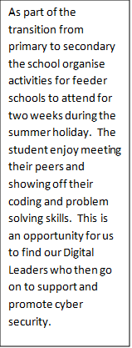

Requirement 8 (Answer sheet 2 of 2)
Copy of minutes
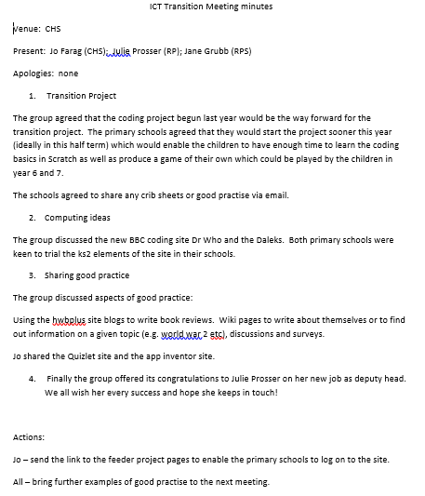

Requirement 8 (Answer sheet 2 of 2)

Requirement 9 - (Rating 0 to 4)
The proposed CyberFirst School/College must describe the school/college’s external engagement to date and future plans. For example, this might cover:
External engagement activities with industry, academia, local schools/colleges and how these add value to its computing / computation and cyber security education programme.
Outreach activities with the wider community and key outcomes to date, for example:
  - With schools/colleges, teachers, governors, under-represented groups, community groups and the like
  - Covering cyber security as well as basic cyber awareness
  - Providing support to other teachers with the teaching of computing / computation and cyber awareness, not necessarily as part of a dedicated computing class
  - Track record of promoting teaching of computing with schools/colleges locally/regionally and leading professional learning for teachers
  - Track record of participating as part of national professional learning programmes and establishing partnerships of organisations and individuals.
☐ 0 - Fail - The proposed CyberFirst School/College has failed on ALL points.

☐ 1 - Preliminary Fail - The proposed CyberFirst School/College has limited description of the school/college’s future plans for external engagement.

☐ 2 - Bronze - The proposed CyberFirst School/College must describe the school/college’s future plans for external engagement.
☐ 3 - Silver - The proposed CyberFirst School/College must describe the school/college’s external engagement to date and future plans.
☒ 4 - Gold - The proposed CyberFirst School/College must describe the school/college’s external engagement to date and future plans.

Additional Guidance
Please take care to clarify in your input what activity is current and what is proposed/planned.

Requirement 9 (Answer sheet 1 of 2)
The school have a partnership with both Cardiff Metropolitan University and Swansea University, this partnership The Cardiff Partnership for Initial Teacher Education comprises Cardiff Metropolitan University and its associated partner schools, working in collaboration with University of Oxford, Cardiff University, Central South Consortium (CSC), Education Achievement Service (EAS), and City of Cardiff Council.
Together, the Cardiff Partnership collaborates to ensure that our student teachers not only achieve, but seek to surpass the professional standards for QTS through high-quality professional education that is rigorously practical and intellectually challenging. The impact on staff and students has meant that they are able to have a better understanding of the importance of working securely and the positive and negative impacts when using social media. The initiatives shared with staff and students are:
- Guest lecture sessions for students and staff
- Invitations for cyber and other ICT (e.g. Robotics) workshops
- A number of students and staff taken up offers of professional certification trainings to CHS students and staff (e.g. Cisco Network security, Cisco CyberOps)
- Career guidance opportunities for students
- Field visits organized by CyberFirst industry partners
- Invitation for competitions (e.g. Hackathon and CTF)
- CPD opportunities for ICT and CS staff at CHS
We also staff are encouraged to engage actively with Cyber Wales Ecosystem: https://cyberwales.net/, this will be advertised and used further in 2021.
Cyber Week at the University of South Wales – Future plans:
All students will be given the opportunity to take part in Cyber Week with the potential to stay in student halls and gain a taste of university living. Within this week learners would undertake CTF activities, competing against other colleges. This exclusive week-long activity will bring together students at the National Cyber Security Academy at the University of South Wales in Newport. They’ll hear from industry leaders, meet professionals in cyber, take part in challenges, and learn about technologies and methodologies. The department has also registered for Cyber Week during October 18th to 22nd 2021, this will allow us to share innovative and up-to-date information with staff and students.

Go on organised Trips – the key trips that have taken place already were a trip to Paris where 40 students travelled to Science and Technology events and 40 students attended the New York to further develop Computer Science. It is anticipated that when Covid19 systems allow, students will continue to explore cyber security through local and national visits such as a visit to Bletchley Park, the National Museum of Computing to study the origins of code breaking using computing.

Compete in national Competitions – there will be a range of competitions including the opportunity to take part in Skills Wales Cyber and Cyber Centurion Competitions.
We have also engaged with Cardiff University for staff development and with Cardiff Metropolitan University for staff and student activities such as the annual “Hackathon”. As part of our future plans for 2021 we will attend the cyber and robotics workshops at the university as well as at Cardiff High School. Staff and students will have the opportunity to attend professional certification training such as CISCO, CyberOps and Network Security. We will advertise and attend field visits organised by CyberFirst industry partners.
Our links with Cardiff Metropolitan who provide access to sixth form level education for school leavers. Our students benefitted from online CPD during lock-down in preparation for university. We are also looking to pilot a scheme to encourage more girls to study STEM subjects with the promotion of female only technology days. This will include guest female speakers who are enjoying successful careers in Cyber Security as well as educational sessions provided by our core team.
Evidence of linking with external organisations to plan industry experience and opportunities:
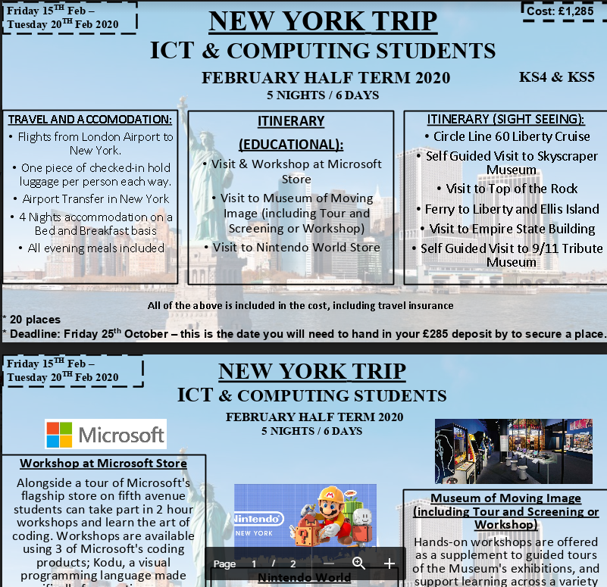
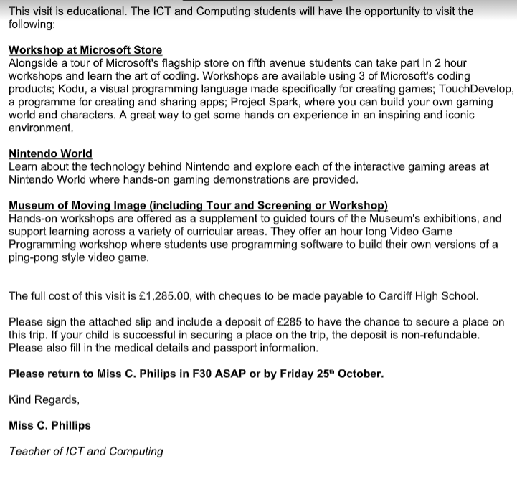
Page Break
Paris Trip: This is further evidence of students enjoying external experiences in computer science by visiting a variety of venues:
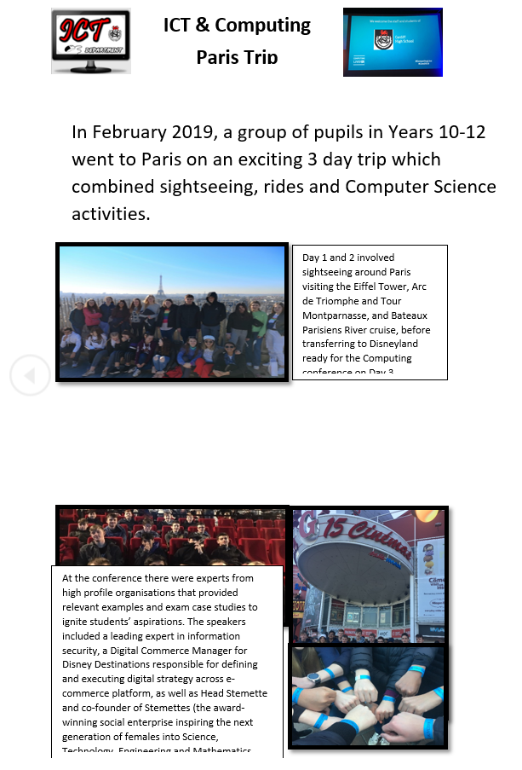

Requirement 9 (Answer sheet 2 of 2)

Requirement 10 - (Rating 0 to 4)
The proposed CyberFirst School/College must participate in/advertise CyberFirst opportunities.

☐ 0 - Fail - The proposed CyberFirst School/College has failed on ALL points.

☐ 1 - Preliminary Fail - The proposed CyberFirst School/College has limited participation in/advertise or have aspirational plans for CyberFirst opportunities.
☐ 2 - Bronze - The proposed CyberFirst School/College must participate in/advertise or have aspirational plans for CyberFirst opportunities.
☐ 3 - Silver - The proposed CyberFirst School/College must participate in/advertise CyberFirst opportunities.
☒ 4 - Gold - The proposed CyberFirst School/College must participate in/advertise CyberFirst opportunities.

Additional Guidance
This can cover any CyberFirst/Cyber Discovery event. Please provide examples of what your school/college has taken part in.
Please take care to clarify in your input what activity is current and what is proposed/planned.

Requirement 10 (Answer sheet 1 of 1)
Wyedean school is committed to developing the next generation of cyber professionals, we have actively engaged with all CyberFirst events. We have developed a curriculum and established unique events to promote CyberFirst across schools in Gloucestershire and Wales. The below includes the opportunities we have created and our future proposal.

CyberFirst Competition/Courses- Wyedean School has entered the CyberFirst Girls Competition annually since 2017. We have embedded cyber education into our schemes of work and teach all students in Year 8 the CyberFirst adventurers’ modules prior to the competition to encourage participation. For two years running this has had a huge impact with every female in year 8 entering the competition in teams. We have worked hard to establish industry connections who act as guardians to our teams and raise aspirations by providing career insights. We were fortunate in 2019 to have a team in the South West final, which inspired our females further into opting for GCSE Computer Science. We have developed videos as part of CyberTV to encourage other schools to take part and have partnered with Welsh schools (Caldicot School, Crickhowell and Cardiff Schools) to help them establish and set up the competition entry at their school. We have welcomed many schools, universities and cyber education training and growth organisations into Wyedean to view our provisions. Each year students are encouraged to attend the CyberFirst courses in Gloucestershire Bristol or Cardiff. Students from Wyedean have attended the adventurers, defenders, futures and advanced courses. We will continue to support and promote these courses and the competition in our school and across all schools.

EmPowerCyber Event -Working in partnership with other schools it became evident that in order to inspire young women to consider a career in cyber security we needed to unite them across schools, showcasing the importance of female unity and empowerment. Wyedean School developed the idea of an EmPowerCyber event. An event that provided a challenging environment of workshops linked to the framework of the CyberFirst competition and run by industries. Inspiring young women by showcasing all possibilities in the field. The event was organised and developed by Wyedean School with the help of Madeline Howard. It was a success and attracted 800 year 8 students from across Gloucestershire and Wales. NCSC has now taken this style of event nationally and we will continue to promote and attend as a school. EmPowerCyber Event was successful in achieving its aims; however, it is clear that we need to fight stereotypes and make Cyber inclusive for all at a young age- males and females. We proposed the idea of a competition for all key stage 3 students run at Cheltenham Science festival, hence how DataFace was developed. We will continue to work with IRIS and Cheltenham Science Festival to ensure the success of this competition.

CyberFirst Modulisation - In order to make cyber accessible to all we developed the CyberFirst course material into lesson and club packs to be shared across schools to help support teachers. The teaching packs have been developed in line with the national curriculum and include assessments. The club packs have been developed to encourage all schools to set up cyber clubs. To date we have developed; CyberFirst Adventurers; CyberFirst Creative and CyberFirst Engineering. We have delivered CPD across CAS groups to make these modules accessible to all schools. We will continue to update these modules to include new development and advancements in computer science and cyber education.

Cyber Discovery- We actively promote cyber discovery and encourage all GCSE and A level students to take part. Many students have gone through to the final stages of the competition. We have helped this platform develop promotional and advertising material. Our teaching staff and students are featured on the videos on their websites to promote its use in school to deliver curriculum content. The Cyber Discovery competition is built into our 2020-2021 schemes of work as an independent homework task at key stage 4 and 5.

The CyberFirst School status will allow us to further promote all CyberFirst events, courses, competition and bursaries across schools, role modelling the importance of cyber education in schools and for all students.

